**Project Title:** GUI Calculator

**Group Members:-**

1. Hashir Kaleem Khan (17K-3948) D1
2. Ibrahim Nadeem (16K-3832) D2
3. Fatir (16K-3821 + did not work at all) D2

**Introduction:-**

This is a GUI based calculator which enables user to perform all mathematical calculations that a modern calculator allows.

**Tools Used:-**

1. Dev C++
2. Microsoft Visual Studio Ultimate 2012(Our GUI has running issues on other versions+ this version is also available on \\netstorage)

**Project Description:-**

This calculator does following operations:

1. Add **2-**Subtract

**3-** Multiply **4-**Divide

**5-**Log **6-**e^n

**7-**Mod **8-**n^x

**9-**Underroot

**10-**All trigonometric functions

**Programming**

In this calculator I have tried to use every possible programming concept. Following is a list of concepts implemented:

**1-Pointer & Dynamic Memory Allocation:-**

The user input gets stored in a temp variable and then a pointer ‘o’ of its size gets dynamically allocated. Then I have assigned the address of temp variable to this pointer so that the input gets stored in it.

**2-Function:-**

The pointer ‘o’ is then passed to a function ‘Calculator’ which performs the user specified mathematical operation.

**3-Loops:-**

Loops are used to ask user to use calculator more than once.

**4-Filing:-**

Filing is used to support GUI phenomenon which is described below.

**5-GUI:-**

Graphical User Interface is used by Visual Studio. For this, what I have done is that the user input gets written in a file ‘function.txt’. The file is then closed and system() runs ‘Scientific Calculator.exe’ which opens GUI calculator with set-upped buttons.

**6-Note:-**

There was no possible use of other concepts like structure, double pointers, pointer functions or strings here so I was unable to use them. **Screenshots of project:** 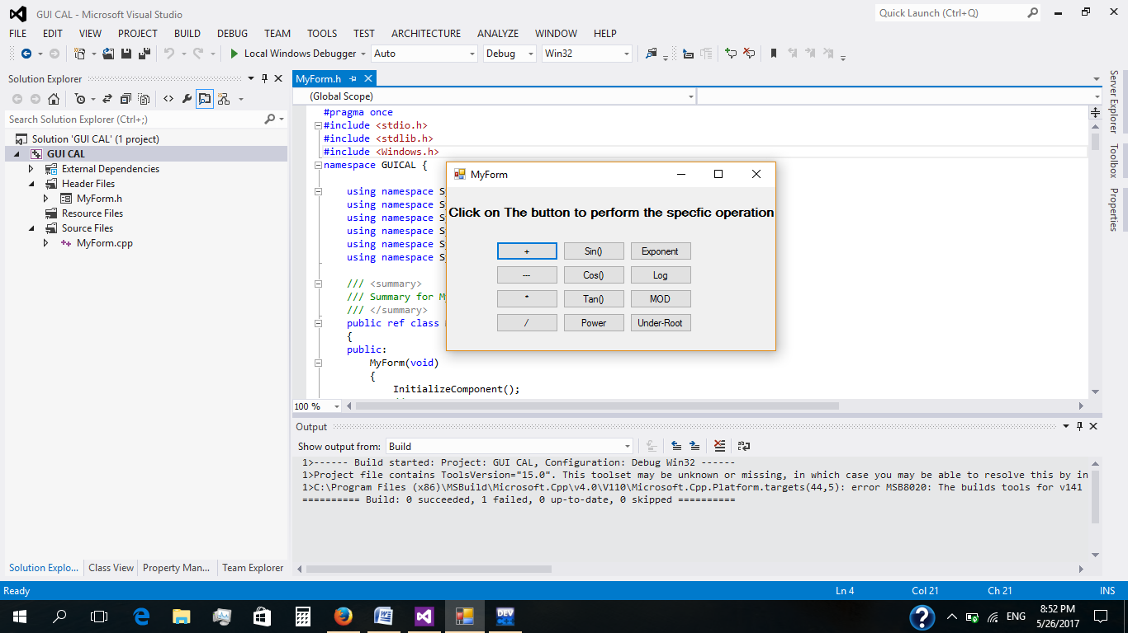

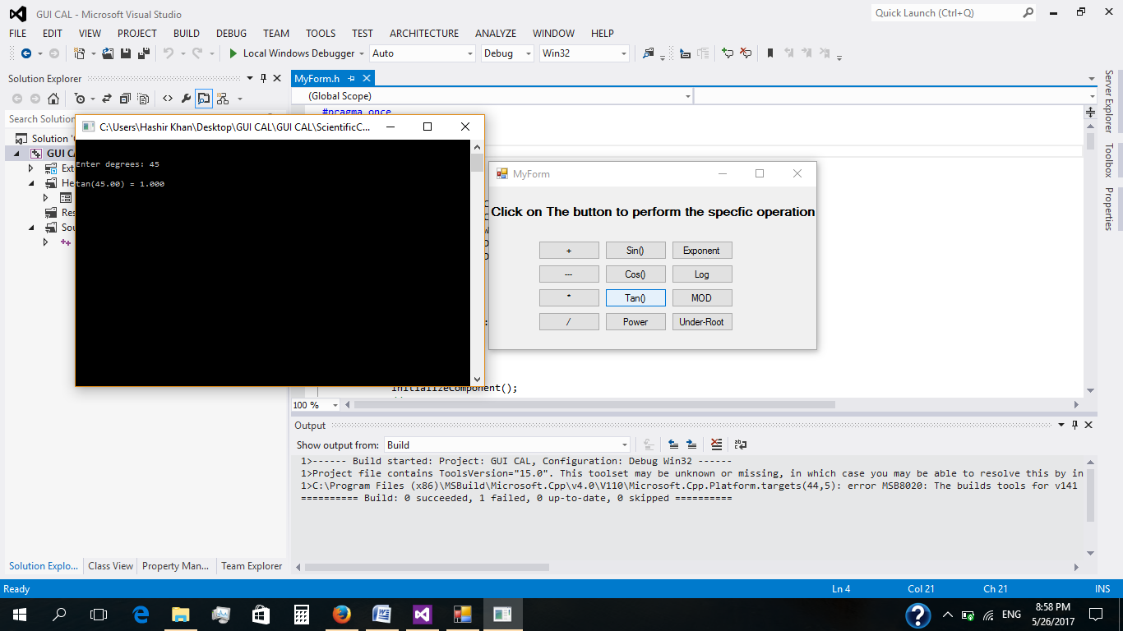

**Thank You!** ☺